

|  |
| --- |
| On Hard Drives & Failure  KE 5107 CA 1 Report |
|  |
| Authored by:  Bharat Nagaraju (A0178258N) Edwin Tam (A0178396J)  Vignesram Andiappan Selvaraj (A0178215A) |

Contents

1. What in Backblazes is this about?
2. Understanding & Exploring Hard Drives
3. Preparing the Data
4. Models for prediction
5. Evaluations

# What in Backblazes is this about?

## Context & Business

Backblaze is a cloud storage provider for developers and IT departments. They run and manage data centers to make sure there’s enough capacity, redundancy, and functional hard drives to read, write, and store data.

As such, it is important that they know the “goodness” of each hard drive – so that they can replace faulty drives early and efficiently.

To achieve that, Backblaze uses SMART statistics of hard drives.

**What are SMART statistics?**

Also known as Self-Monitoring, Analysis and Reporting Technology, SMART statistics is a monitoring system included in hard drives that reports on various attributes of the state of a given drive.

There are about 70 SMART stats ([source](https://www.backblaze.com/blog-smart-stats-2014-8.html)) available… some of which can be used to predict the failure rate of a hard drive.

However, hard drives – even those from the same manufacturer – provide inconsistent SMART stats.

What’s the Business Problem?

As said earlier, Backblaze’s business is based on the “goodness” of their hard drives. They need to know when a hard drive will fail early and efficiently.

Thus, we can ask:

1. Which SMART stat contributes to failure or success rates of a hard drive?
2. What would be a good model to predict hard drive failure?

Obviously, we can use the answers to focus on a few SMART stats and models. With these questions in mind, we now look at the available datasets. Where do we get this data?

Backblaze logs Hard Drive Test Datasets on their [webpage](https://www.backblaze.com/b2/hard-drive-test-data.html). Each zipped file contains daily snapshots for each of their 40,000 Hard Drives. This also includes hard drive statuses (Failure or OK).

We have selected to use 2018 dataset instead of across the years. Of note, the 2018 dataset contains additional SMART attributes which we will not use in this CA.

# Understanding & Exploring Hard Drives

## **Overview**

We are currently using 2018 data from Back Blaze. These are SMART stats for each hard disk drive in operation and whether it fails or not. The data is mapped across days in a year.

Please note that R Code is interspersed within this section

**Short Description of Dataset** The dataset is divided into 2 distinct parts:

1. Descriptors

These include Hard Drive information (e.g. model, serial number), test dates, Failure status etc. Failure Status is the ground truth label for each Hard Drive.  
Columns associated are date, serial\_number, model, capacity\_bytes, failure

1. SMART Stats

These are the actual stats for each Hard Drive. Each stat has a raw and normalised version. According to the documentation, there will be missing values as hard drives do not necessarily report all SMART stats. Columns associated are smart\_1\_normalized, smart\_1\_raw, smart\_2\_normalized, smart\_2\_raw, smart\_3\_normalized, smart\_3\_raw, smart\_4\_normalized, smart\_4\_raw, smart\_5\_normalized, smart\_5\_raw, smart\_7\_normalized, smart\_7\_raw, smart\_8\_normalized, smart\_8\_raw, smart\_9\_normalized, smart\_9\_raw, smart\_10\_normalized, smart\_10\_raw, smart\_11\_normalized, smart\_11\_raw, smart\_12\_normalized, smart\_12\_raw, smart\_13\_normalized, smart\_13\_raw, smart\_15\_normalized, smart\_15\_raw, smart\_22\_normalized, smart\_22\_raw, smart\_177\_normalized, smart\_177\_raw, smart\_179\_normalized, smart\_179\_raw, smart\_181\_normalized, smart\_181\_raw, smart\_182\_normalized, smart\_182\_raw, smart\_183\_normalized, smart\_183\_raw, smart\_184\_normalized, smart\_184\_raw, smart\_187\_normalized, smart\_187\_raw, smart\_188\_normalized, smart\_188\_raw, smart\_189\_normalized, smart\_189\_raw, smart\_190\_normalized, smart\_190\_raw, smart\_191\_normalized, smart\_191\_raw, smart\_192\_normalized, smart\_192\_raw, smart\_193\_normalized, smart\_193\_raw, smart\_194\_normalized, smart\_194\_raw, smart\_195\_normalized, smart\_195\_raw, smart\_196\_normalized, smart\_196\_raw, smart\_197\_normalized, smart\_197\_raw, smart\_198\_normalized, smart\_198\_raw, smart\_199\_normalized, smart\_199\_raw, smart\_200\_normalized, smart\_200\_raw, smart\_201\_normalized, smart\_201\_raw, smart\_220\_normalized, smart\_220\_raw, smart\_222\_normalized, smart\_222\_raw, smart\_223\_normalized, smart\_223\_raw, smart\_224\_normalized, smart\_224\_raw, smart\_225\_normalized, smart\_225\_raw, smart\_226\_normalized, smart\_226\_raw, smart\_235\_normalized, smart\_235\_raw, smart\_240\_normalized, smart\_240\_raw, smart\_241\_normalized, smart\_241\_raw, smart\_242\_normalized, smart\_242\_raw, smart\_250\_normalized, smart\_250\_raw, smart\_251\_normalized, smart\_251\_raw, smart\_252\_normalized, smart\_252\_raw, smart\_254\_normalized, smart\_254\_raw, smart\_255\_normalized, smart\_255\_raw, LatestRec

**Exploratory Data Analyses (EDAs)** As the dataset is time-bound, we will be looking at how time affects the dataset in addition to the usual EDA techniques.

1. Counts & Dimensions of Descriptors: To understand volume & “uniqueness” across time

* Dimension of dataset
* Count of dates, hard drives, failed (1) vs OK (0) hard drives
* Proportion of failed vs OK hard drives

1. Deep Dive into SMART Stats: To understand how much is missing, what’s missing, and outliers

* Data Summary
* Missing data & When they are missing
* SMART Stats with no variances
* Outliers

1. Correlations between features: To see if there are similar features
2. Next Steps

The rest of this section will highlight interesting findings and possbile approaches. Please note that R code is embedded within the document.

### Counts and Dimensions of Descriptors

In this EDA, we are concerned about the shape, form, and size of the descriptors.

**Dataset Dimensions**

The dataset has these dimensions: 32056, 106

1. Observations: 32056
2. Features: 106

**1. Unique Dates**

There are **288** unique dates in 32056 observations. That means some observations might be “bunched” up in time. Let’s have a look at how observations are distributed across time

temp <- hd %>%

group\_by(date, failure) %>%

summarize(count=n())

xyplot(count~date, temp, type="l", auto.key=TRUE, main="Distribution of Observations over Time", ylab="Observations")

**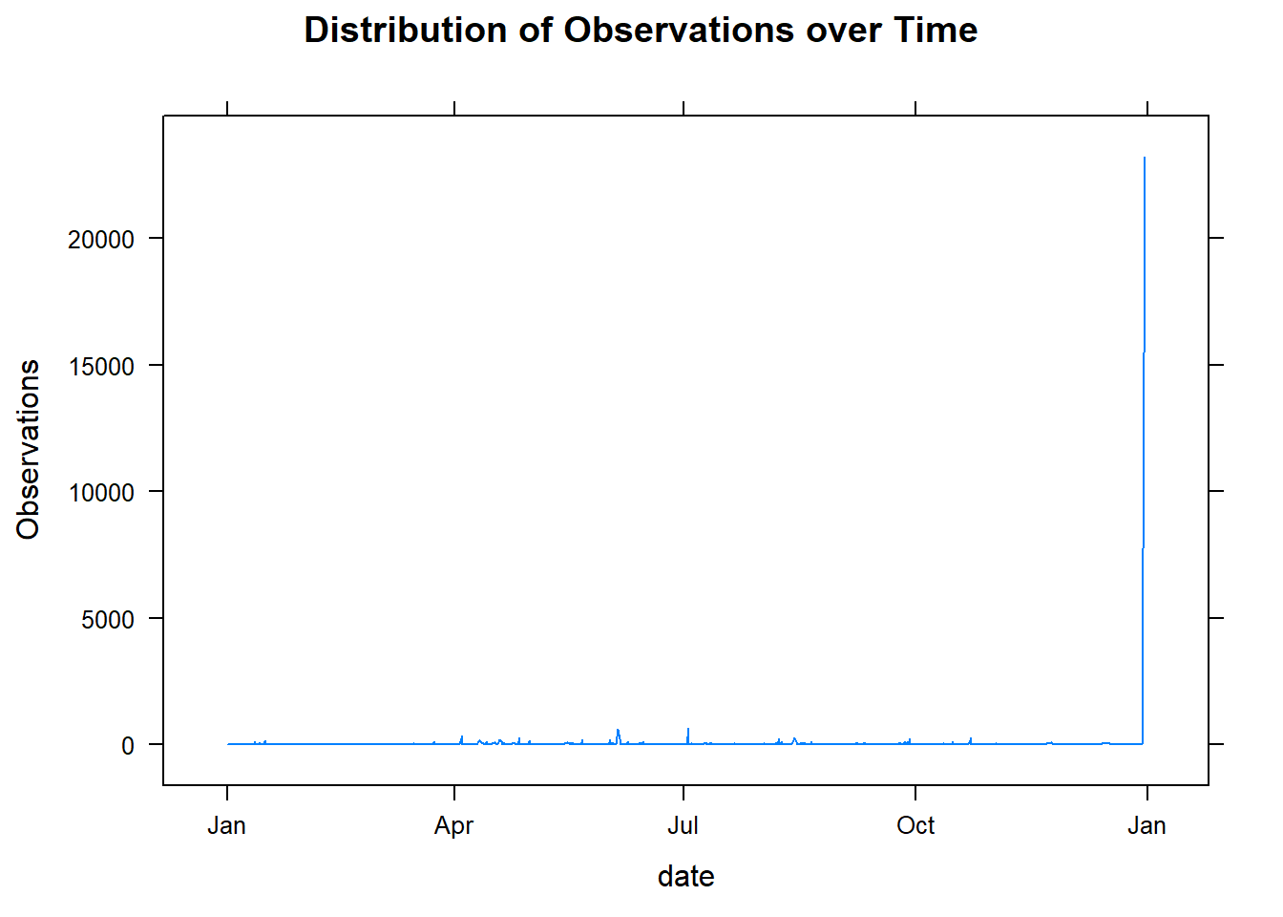**

It’s quite apparent that there’s an **observation spike near the end of the year**.

**2. How many Hard Drives do we have?**

There are **32054** Hard Drives in 32056 observations. Almost every observation is matched to a unique hard drive

**3. How many failed (1) vs OK (0) Hard Drives are there?**

count(hd, failure)

|  |
| --- |
|  |

| failure  <dbl> | n  <int> |
| --- | --- |
| 0 | 31475 |
| 1 | 581 |

As the table shows, we have a disporportionate breakdown of failed (1) vs OK (0) Hard Drives. There are only 1.8124532% failures. This means that we will have to **rebalance the dataset in some way.**

Following on this (dis)proportion, what is the **distribution of failed (1) vs OK (0) hard drives across time?**

xyplot(count~date, temp, groups=failure, type="l", auto.key=TRUE, main="Distribution of Failed (1) vs OK (0) Hard Drives over Time", ylab="NUmber of Hard Drives")

**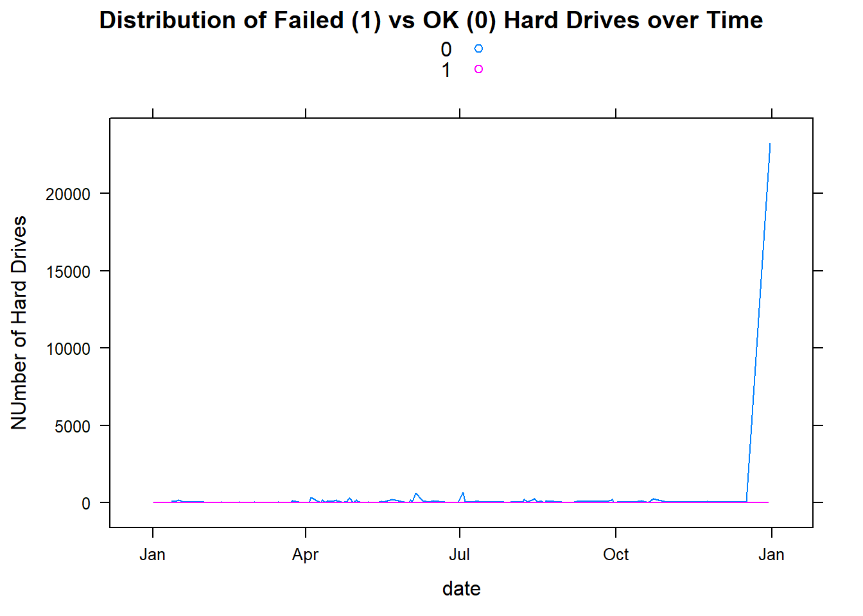**

This is an expected result. We could probably get rid of some OK Hard Drives that are near the end of the year.

#### Counts & Dimensions Summary

OK (0) Hard Drives tend to “bunch” up towards the end of the year. This creates an imbalance in the dataset proportion between Failed (1) and OK (0) Hard Drives. The dataset will need to be rebalanced before running predictive models later.

### Deep Dive into SMART Stats

Now that we know what’s in our Descriptors, it’s time to look at the actual predictors (in this case, SMART Stats of hard drives).

**1. Summary of SMART Stats**

summary(hd [6:ncol(hd)])

See

As this lengthy summary shows, some columns are empty (e.g. “smart\_2\_normalized”, smart\_2\_raw“); some have just 1 value (e.g.”LatestRec“,”smart\_251\_normalized"); and what is the difference between normalised and raw data columns?

For the rest of this section, we will look for the amount of missing data, columns with 0 variances, and outliers in columns that remain.

**2. How Much Data is Missing?**

missingHD <- colSums(is.na(hd))/nrow(hd)\*100

This is best answered as such:

1. How many columns have no missing data?

27 (about 25.4716981%)

1. How many columns have < 50% missing data?

48 (about 45.2830189%)

1. How many columns have > 90% missing data?

40 (about 37.7358491%)

This leads us to the next question: **Which columns are Missing then?**

barchart(sort(missingHD,decreasing = TRUE), xlab = "% of missing values", main="Missing Values in Data Columns")

**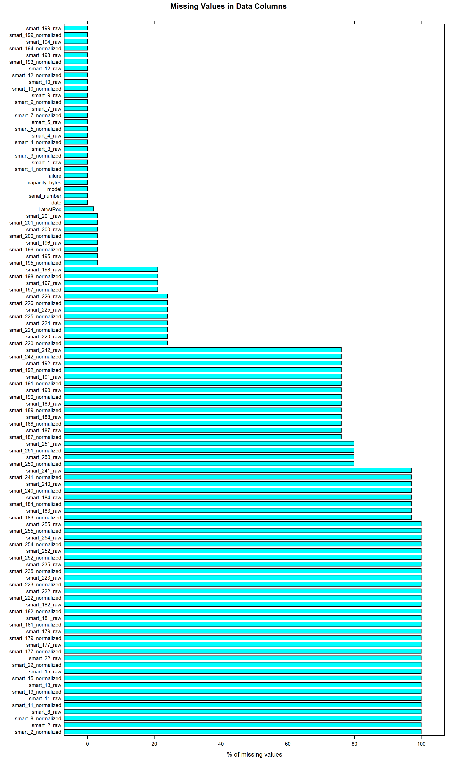**

We can remove columns with > 90% missing values without affecting the dataset too much. We should get rid of these columns: smart\_2\_normalized, smart\_2\_raw, smart\_8\_normalized, smart\_8\_raw, smart\_11\_normalized, smart\_11\_raw, smart\_13\_normalized, smart\_13\_raw, smart\_15\_normalized, smart\_15\_raw, smart\_22\_normalized, smart\_22\_raw, smart\_177\_normalized, smart\_177\_raw, smart\_179\_normalized, smart\_179\_raw, smart\_181\_normalized, smart\_181\_raw, smart\_182\_normalized, smart\_182\_raw, smart\_183\_normalized, smart\_183\_raw, smart\_184\_normalized, smart\_184\_raw, smart\_222\_normalized, smart\_222\_raw, smart\_223\_normalized, smart\_223\_raw, smart\_235\_normalized, smart\_235\_raw, smart\_240\_normalized, smart\_240\_raw, smart\_241\_normalized, smart\_241\_raw, smart\_252\_normalized, smart\_252\_raw, smart\_254\_normalized, smart\_254\_raw, smart\_255\_normalized, smart\_255\_raw

Apart from missing values, what columns contain only 1 value? Columns with constant values shouldn’t have an effect on the Hard Drive’s failure/OK rate. We can use variance as a measure to identify these columns.

**3. Which Columns have only 1 value? Measured by Variance of 0**

varHD <- apply(hd, 2, var,na.rm=TRUE)

noVar <- varHD[!is.na(varHD)]

There are 11 columns with constant values.

**Remove these 0 variance columns:** capacity\_bytes, smart\_3\_raw, smart\_10\_normalized, smart\_10\_raw, smart\_226\_normalized, smart\_240\_normalized, smart\_241\_normalized, smart\_242\_normalized, smart\_250\_normalized, smart\_251\_normalized, LatestRec

## **Intermission**

We now know the columns that have >90% missing values and 0 variance. Before we conduct further EDAs, it would be useful to remove these columns from our dataset. In addition, we are also taking out normalized variables.

*# removing columns with > 90% missing values, 0 variance, and -Normalized variables*

t <- hd[,missingHD <90]

t <- t[, -which(names(t) %**in**% names(noVar[noVar==0]))]

t <- t[, -grep("normalized$", colnames(t))]

After removal, we are left with 32 columns.

These are the variables that make the cut: date, serial\_number, model, failure, smart\_1\_raw, smart\_4\_raw, smart\_5\_raw, smart\_7\_raw, smart\_9\_raw, smart\_12\_raw, smart\_187\_raw, smart\_188\_raw, smart\_189\_raw, smart\_190\_raw, smart\_191\_raw, smart\_192\_raw, smart\_193\_raw, smart\_194\_raw, smart\_195\_raw, smart\_196\_raw, smart\_197\_raw, smart\_198\_raw, smart\_199\_raw, smart\_200\_raw, smart\_201\_raw, smart\_220\_raw, smart\_224\_raw, smart\_225\_raw, smart\_226\_raw, smart\_242\_raw, smart\_250\_raw, smart\_251\_raw

**4. How Many Outliers Are There In Each Column?**

**for** (i **in** 5:32) {

d1 <- t[,i]

d1 <- d1[!is.na(d1)]

n <- colnames(t)[i]

show(bwplot(d1, xlab="Values", ylab="", main=n))

}

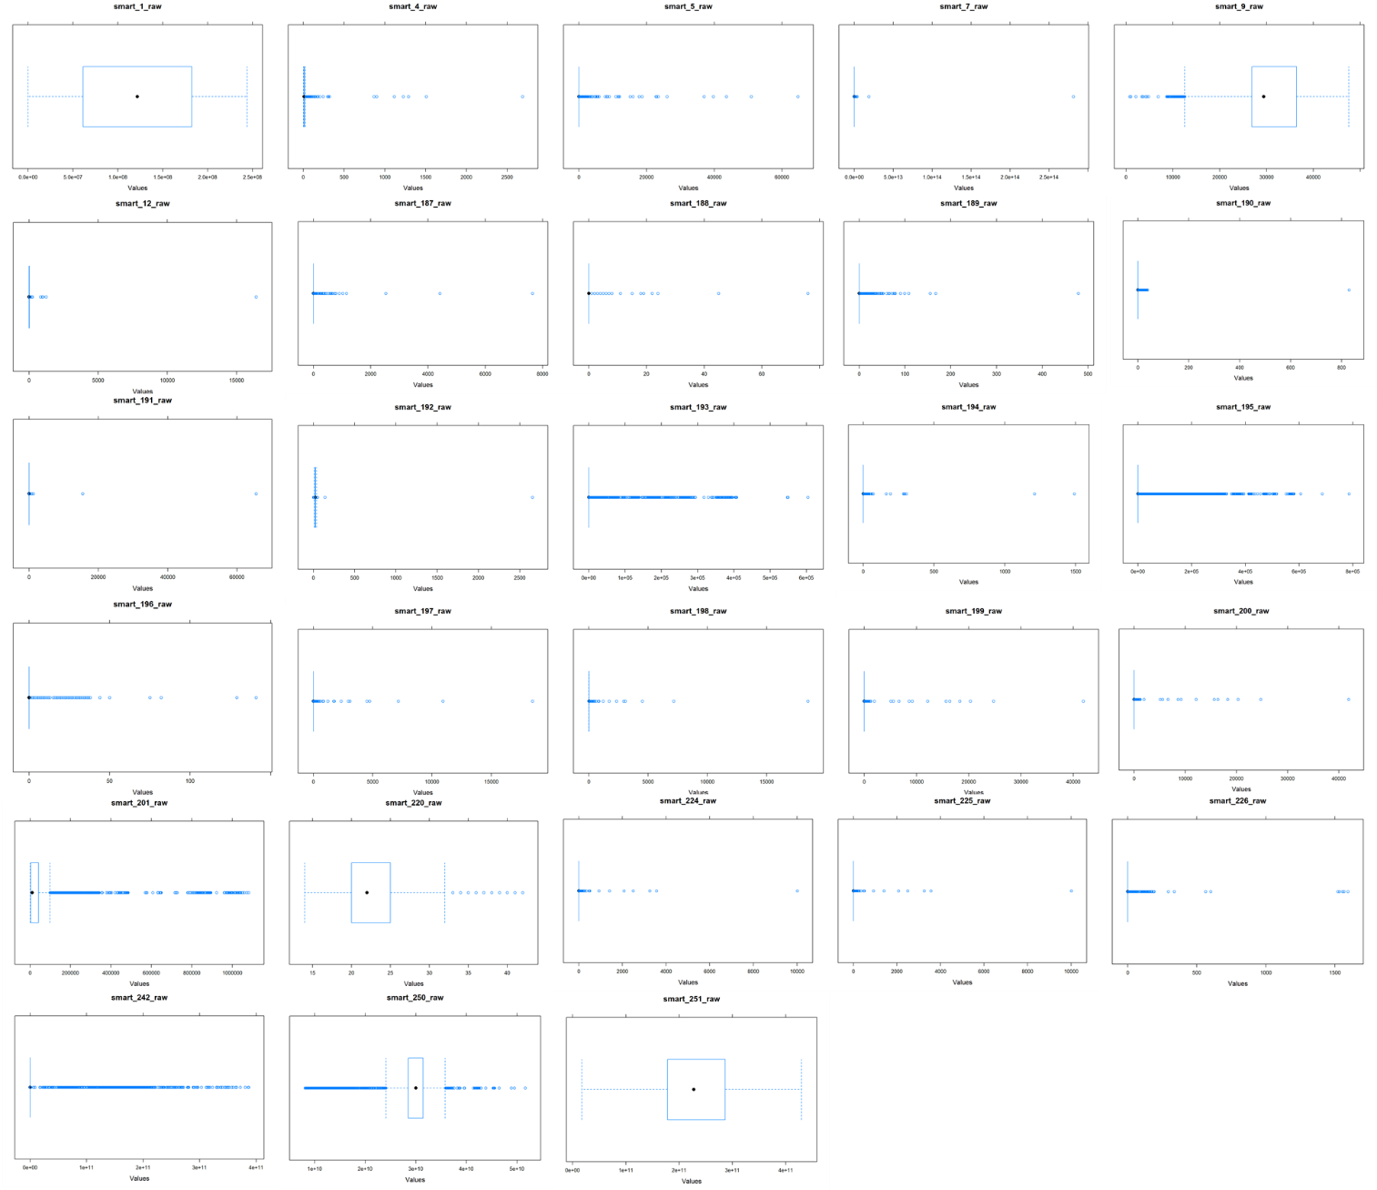

We notice that a variety of attributes are skewed left or right. However we suspect that the skew is due to them having some kind of significance in predicting the output (1 or 0) as SMART Stats are only reported on an ad-hoc basis.

We will investigate further when we build the models.

**5. When would Data Go Missing?**

This dataset contains time data and, in addition, Hard Drives when queried do not necessarily reveal certain SMART Stats. We’d like to see if a patterns appear when we look at the volume of missing values against time.

t$naVal <- rowSums(is.na(t))

xyplot(naVal~date, t, type="l", main="Volume of NAs across Time", auto.key = TRUE, xlab="Date", ylab="Count of columns with NA values")

**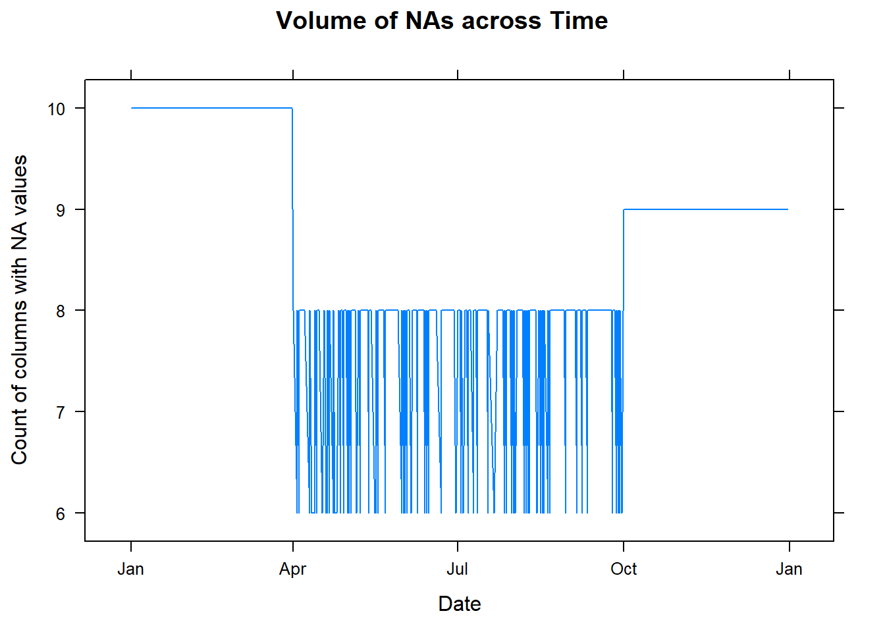**

The chart shows that more columns are missing between Jan to Apr. Fewer during Apr to Oct (Q2 & Q3).

We would consider **using just the Apr to Oct duration for our prediction models, and filling in the missing values using a replacement technique**.

## **3. Correlations between features**

Lastly we investigate the correlations between features. Ideally, the features shouldn’t show high correlations (>0.8) between each other. If so, we will have to remove either one.

This correlation was conducted using “pairwise.complete.obs”; otherwise the NAs would simply render the correlations moot.

a <- cor(t[6:32], use = "pairwise.complete.obs", method=”pearson”)

## Warning in cor(t[6:32], use = "pairwise.complete.obs"): the standard

## deviation is zero

corrplot(a, method="square")

a <- cor(t[6:32], use = "pairwise.complete.obs", method=”spearman”)

corrplot(a, method="square")

|  |  |
| --- | --- |
| **C:\Users\skybe\AppData\Local\Packages\Microsoft.Office.Desktop_8wekyb3d8bbwe\AC\INetCache\Content.MSO\36554359.tmp**  Pearson | C:\Users\skybe\AppData\Local\Packages\Microsoft.Office.Desktop_8wekyb3d8bbwe\AC\INetCache\Content.MSO\8ABA0937.tmp  Spearman |

The plot shows high correlations between:

1. smart\_4\_raw | ~~smart\_192\_raw~~
2. smart\_4\_raw | ~~smart\_194\_raw~~
3. smart\_9\_raw | ~~smart\_196\_raw~~
4. smart\_9\_raw | ~~smart\_250\_raw~~
5. smart\_9\_raw | ~~smart\_251\_raw~~
6. smart\_192\_raw | ~~smart\_196\_raw~~
7. smart\_193\_raw | smart\_242\_raw
8. smart\_195\_raw | ~~smart\_196\_raw~~
9. smart\_198\_raw | ~~smart\_197\_raw~~
10. smart\_199\_raw | ~~smart\_200\_raw~~
11. smart\_198\_raw | ~~smart\_220\_raw~~
12. smart\_224\_raw | ~~smart\_225\_raw~~
13. smart\_242\_raw | ~~smart\_250\_raw~~

Crossed out variables (e.g. ~~smart\_225\_raw)~~ should be dropped from the dataset. In addition, we will keep the following variables: smart\_4\_raw; smart\_9\_raw; smart\_193\_raw; smart\_195\_raw; smart\_198\_raw; smart\_199\_raw; smart\_198\_raw; smart\_224\_raw; smart\_242\_raw.

## **Next Steps**

1. Remove columns with > 90% missing values, normalised columns, and columns with 0 variances
2. Remove columns based on high correlation findings
3. Select sub-section of observations that have the most data available
4. Fill in in missing values using averages src: [Towards Data Science](https://towardsdatascience.com/how-to-handle-missing-data-8646b18db0d4))

# Preparing the Data

|  |
| --- |
| Subtitle Text Here To get started right away, just tap any placeholder text (such as this) and start typing to replace it with your own.  Want to insert a picture from your files or add a shape, text box, or table? You got it! On the Insert tab of the ribbon, just tap the option you need. |
| *“Find even more easy-to-use tools on the Insert tab, such as to add a hyperlink or insert a comment”* |
| To get started right away, just tap any placeholder text (such as this) and start typing to replace it with your own.  Want to insert a picture from your files or add a shape, text box, or table? You got it! On the Insert tab of the ribbon, just tap the option you need. |

# Building Models to Predict Good Hard Drives

|  |
| --- |
| Subtitle Text Here To get started right away, just tap any placeholder text (such as this) and start typing to replace it with your own.  Want to insert a picture from your files or add a shape, text box, or table? You got it! On the Insert tab of the ribbon, just tap the option you need. |
| *“Find even more easy-to-use tools on the Insert tab, such as to add a hyperlink or insert a comment”* |
| To get started right away, just tap any placeholder text (such as this) and start typing to replace it with your own.  Want to insert a picture from your files or add a shape, text box, or table? You got it! On the Insert tab of the ribbon, just tap the option you need. |

# Did It Work (Or Evaluating our Models)?

|  |
| --- |
| Subtitle Text Here To get started right away, just tap any placeholder text (such as this) and start typing to replace it with your own.  Want to insert a picture from your files or add a shape, text box, or table? You got it! On the Insert tab of the ribbon, just tap the option you need. |
| *“Find even more easy-to-use tools on the Insert tab, such as to add a hyperlink or insert a comment”* |
| To get started right away, just tap any placeholder text (such as this) and start typing to replace it with your own.  Want to insert a picture from your files or add a shape, text box, or table? You got it! On the Insert tab of the ribbon, just tap the option you need. |

# What in Black Blazes is this about?

|  |
| --- |
| Subtitle Text Here To get started right away, just tap any placeholder text (such as this) and start typing to replace it with your own.  Want to insert a picture from your files or add a shape, text box, or table? You got it! On the Insert tab of the ribbon, just tap the option you need. |
| *“Find even more easy-to-use tools on the Insert tab, such as to add a hyperlink or insert a comment”* |
| To get started right away, just tap any placeholder text (such as this) and start typing to replace it with your own.  Want to insert a picture from your files or add a shape, text box, or table? You got it! On the Insert tab of the ribbon, just tap the option you need. |